**Drill-through demo:**

This section demonstrates the drill through feature in this report.

"Market" is one of the drill-through fields added to the drill-through well of the hidden "Order Details" page. Please refer to the column chart and the grey button at the top right of Figure A. This button is configured to highlight whenever a field from the drill-through well is selected on the report page. In Figure B, the "US Market" has been selected, and you can see the “View Details” button highlighted based on conditional formatting rules. Clicking this button navigates the user to the Order Details page. The user can return to the original page using the “Back” button.

***Figure A***

***Figure B: View details button***

***Figure C: Order details tab***

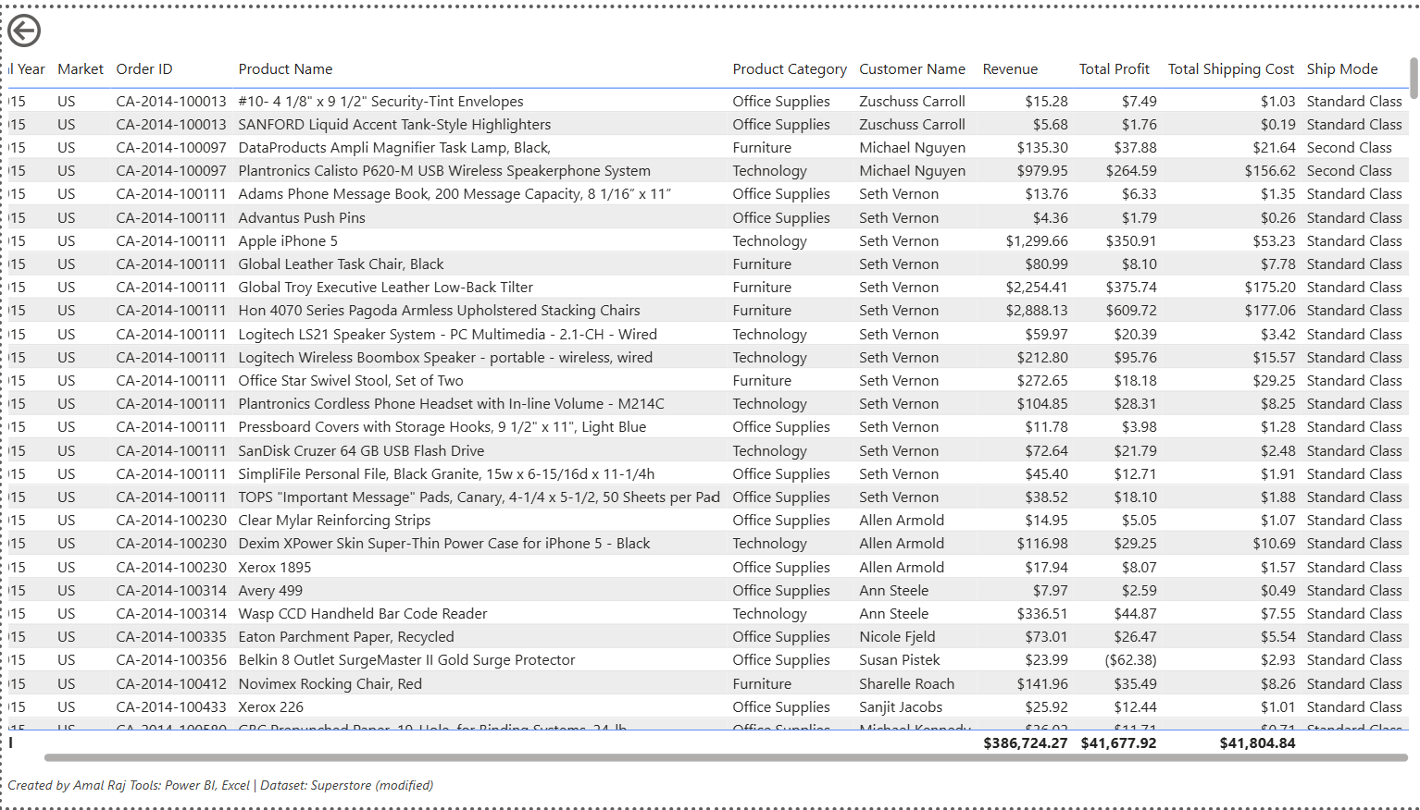

**Row level security (RLS) demo:**

This section demonstrates the Row-Level Security (RLS) feature implemented in the report. Figure D displays a table of Regional Leaders, each associated with their respective email address. In Figure E, the report is viewed as Sherly Rajan, the APAC Vice President. As shown in Figure F, the table is filtered to display only Sherly Rajan’s data. Figure G presents the report page showing details exclusively for the APAC region. (For comparison, refer to Figure A for the original unfiltered view of this page.)

***Figure D:***

***Figure E: Viewing the report as APAC VP***

***Figure F: Market VP table filtered through RLS***

***Figure G: Sales Performance page filtered through RLS***

